Develop a WPF application following the User Interface requirements for the MapFileAnalyzer application. Your project will be named MemoryAnalyzer.

Use as an initialization file the SubsystemsAndFiles.txt file.

Add the following fields to your file:

* **ViewsToDisplay**= -> that can have one of following values: NoViews, OriginalView, BudgetOverview, OriginalViewAndBudgetOverview, OriginalViewAndMemoryPartitions, All3Views. This should indicate the number of tabs in the left panel. Each tab should have at least one sub tab.
* **NumberOfSubTabs**=1 This is an *optional* field. If you use it, each main tab will have the number of sub tabs indicated by the field, otherwise there will be only 1 sub tab for each main tab.
* **pathToOSFile** - should indicate the path to the OS_MemoryProtection.c file. This is the path you will send as a parameter later in your application in order to read the content of the OS File using the memory partitions parser you have already implemented.

OBS: Based on your implementation of the Memory Partitions parser, you can decide how to create the connection to the MANUAL ADDRESSES and MANUAL SYMBOLS. You can use another file (and add the path to it here) or you can simply add them here.

We will consider the **SubsystemsAndFiles.txt file valid** if:

* it has at least 1 subsystem, 1 file, 1 section declared.
* it has the field ViewsToDisplay initialized.

**IMPORTANT**

* If there are no subsystems/files/sections, the initialization file is invalid and an error form should be displayed. The main form will show the "No Views" view.
* If the field *ViewsToDisplay* is missing or it has a wrong value, the initialization file is NOT valid and an error form should be displayed. The main form will show the "No Views" view.

The tree built based on subsystems/files/sections (with the TOTAL node as a root/main parent) will be displayed in the Original View tab.

The BudgetOverview tab can be empty (add sub tabs and a tree component to it) or you can display the same structure displayed for the OriginalView.

**PARTITIONING VIEW**

The Partitioning View should have a main, TOTAL node that has a list of Memory Partitions.

The columns in the data table for the memory partitions should be:

* Name
* Size
* StartAddress
* EndAddress.

The List of memory partitions in the TOTAL node should have all the memory partitions (OS file and manual defined), merged. The size of the TOTAL node should be the sum of sizes for all memory partitions if possible, otherwise NotApplicable.

**Optional Features:**

* Ignore Components - read it from the initialization file as a 1/0 value. If 1 -> the sections should not be shown in the tree in the left panel and the checkbox in the menu is checked. If 0 -> show the sections in the tree, checkbox is unchecked. The user can change this view in the UI.
* Memory Partitions - try to connect the Sections' addresses in the Start-End Addresses for each memory partition. If found, add the section to a List of Sections corresponding to the MemoryPartition.
* The Ram Usage % and Rom Usage % can all be randomly assigned (values between 0-150%) or in order to have different values you can set a rule:
  + if a subsystem has both subsystems and files -> assign a random value
  + if it only has files -> set it to -1
  + if it only has subsystems use NaN or Infinty

**Example** of tree and data table when a file has both files and sections (same when it only has files):

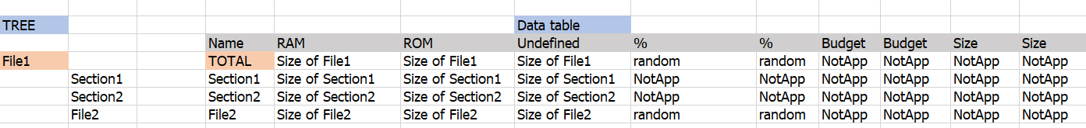

Example of tree and data table when a file only has sections. Section1 and Section2 will be shown in the tree only if Ignore Components is set to 0 (false). If you don't implement the Ignore Components feature the sections will not be shown in the tree.

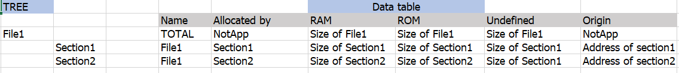

**LOGGER**

A text area that appears when the user clicks the logger button. The text can be large and the user should have the possibility to resize the text area. Do not let the user resize the area until it disappears, or it covers the entire application.

Add your information about the program there (infos, errors, exceptions etc). **Do not** load the text from a file.

